WENDOVER U3A Travel Team Receipt – Cogges Manor Farm and Witney Blanket Hall
Thursday 11th October Cost £23.00 including morning coffee
Departure time from opp. The George 8.30 opp. Ashbrook 8.35 and Bedgrove at 8.45am
On arrival in Witney there will be two groups for the day’s visits:
Group 1 at Blanket Hall for coffee and biscuits in Pie Shop then 45 minutes tour and talk. Free time for lunch at the Pie shop or elsewhere in Witney and walk (approx. 15 mins) to Cogges Manor Farm for 2.15pm tour approximately 40 minutes. Time to explore the grounds and for a cup of tea in the café before boarding the coach at Cogges Farm 4.15pm. A map will be provided.
Group 2 will proceed to Cogges Manor Farm for coffee and biscuits and to order their lunch. Tour at 10.30am, approximately 40 minutes. After lunch board the coach for 2.00 pm departure for 2.15 pm visit to Blanket Hall for 45 min. tour and talk with time for tea afterwards and a look around Witney before boarding the coach at Blanket Hall at 4.25 pm.
Coach to pick up Group 1 at 4.15 pm and return to Blanket Hall for Group 2 at 4.25 pm.
Cogges Farm 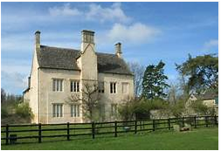  The Manor Farm is a beautifully preserved collection of Cotswold stone farm buildings set in its own grounds. A popular location it has been used for shows from Countryfile to ITV period dramas Downton Abbey | The Blanket Hall 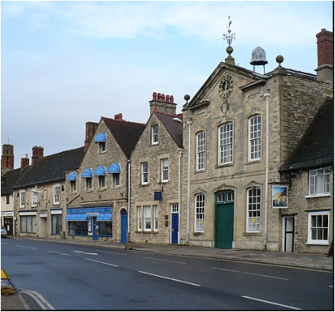  Witney Blanket Hall was built in 1721 by the Company of Blanket Makers. For over 120 years, every blanket woven in the town came to the Hall to be weighed and measured, and upstairs in the Great Room the Company set the Rules for the Trade. Since1845 it has had various uses.

To Book contact wend.U3A.chairman@gmail.com

